Sòals id sógns
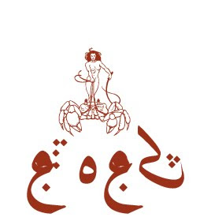
Sòals id Sógns
:::
Seals and Signs

Sleé ren sòlé sòals id sógns aplòaèng raedd s'gruk. Wéy usò s'affbaan alwògwít id jìrésmánd, sha s' list lórt, dí s'ditlàs ladd s'wèffént máems id stanzas, wééwùé lejíng iz másóblà dí wéèdde s'delen euidalànts ladd s'alwògwít:
:::
Here are some seals and signs appearing in the book. The use the affelian alphabet and correspond, for the most part, to titles of the different poems and stanzas, therefore making it possible to derive the roman equivalents of the alphabet:
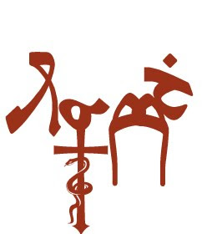
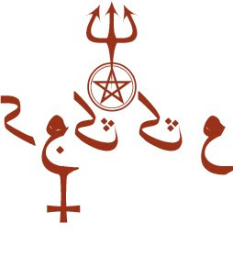
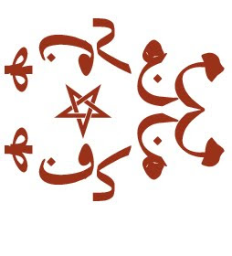
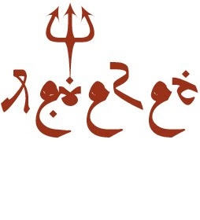
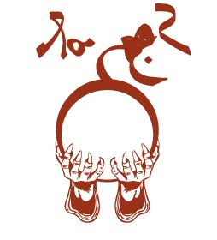
by Ayndryl on Tuesday, December 22, 2009
Labels Ladd cryptolect

